Form No. 6
The following Form No. 6 is required to be filled by those students who have attained the age of 18 yrs. as on January 1, 2012 and have not been enrolled in the voter’s list as yet.
They have to submit it to Mrs. Renu Chander as early as possible.
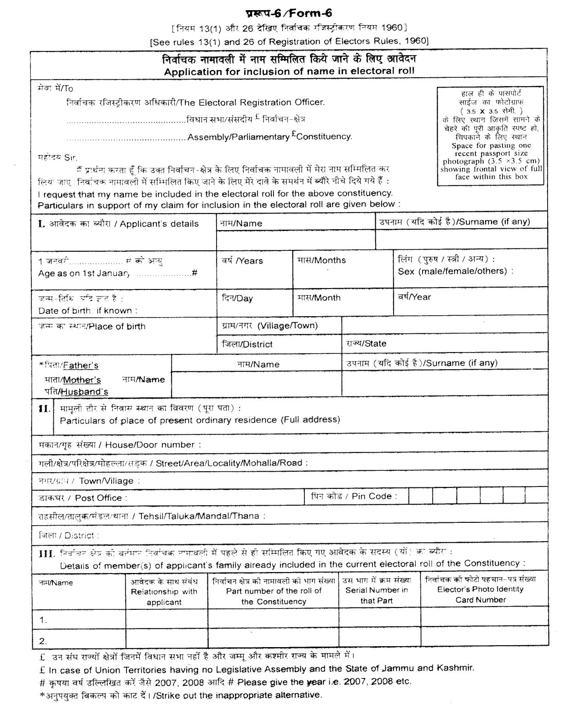

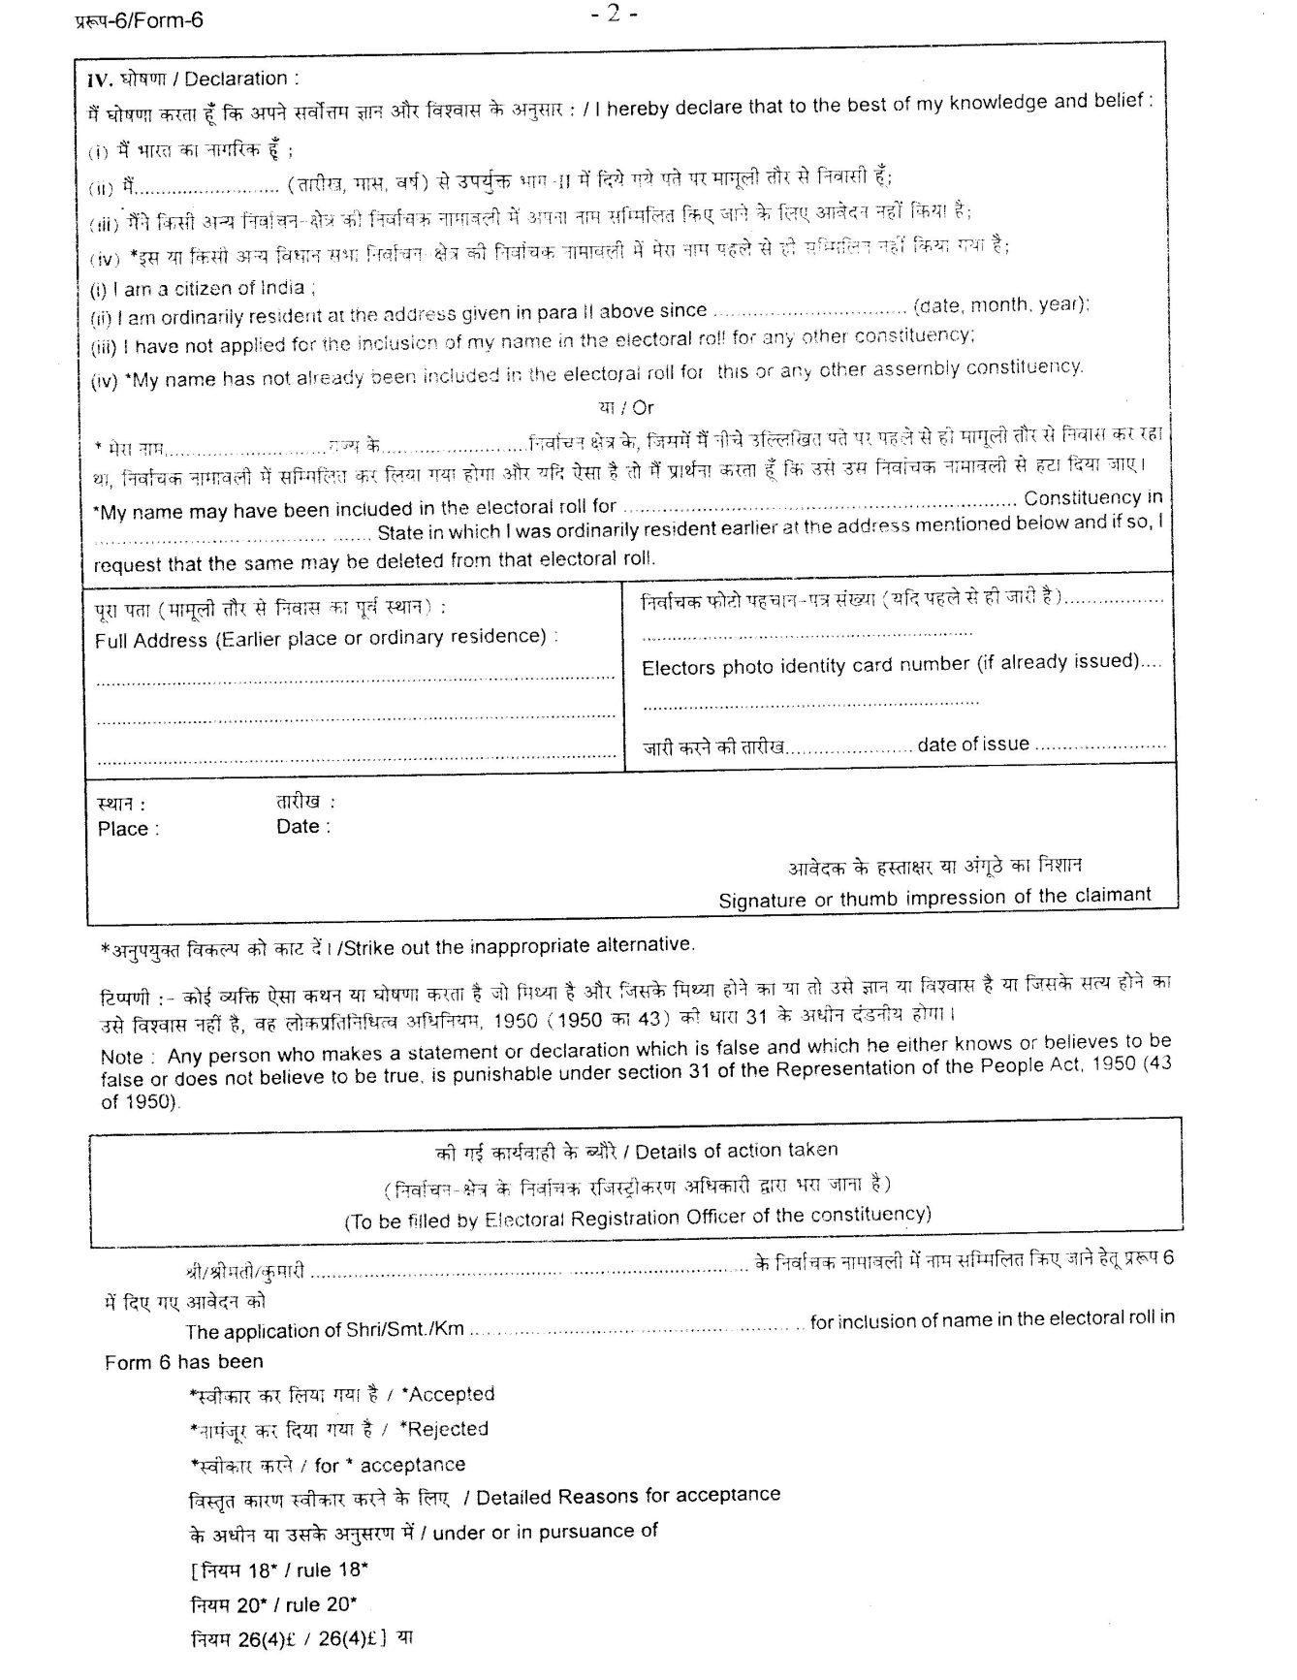

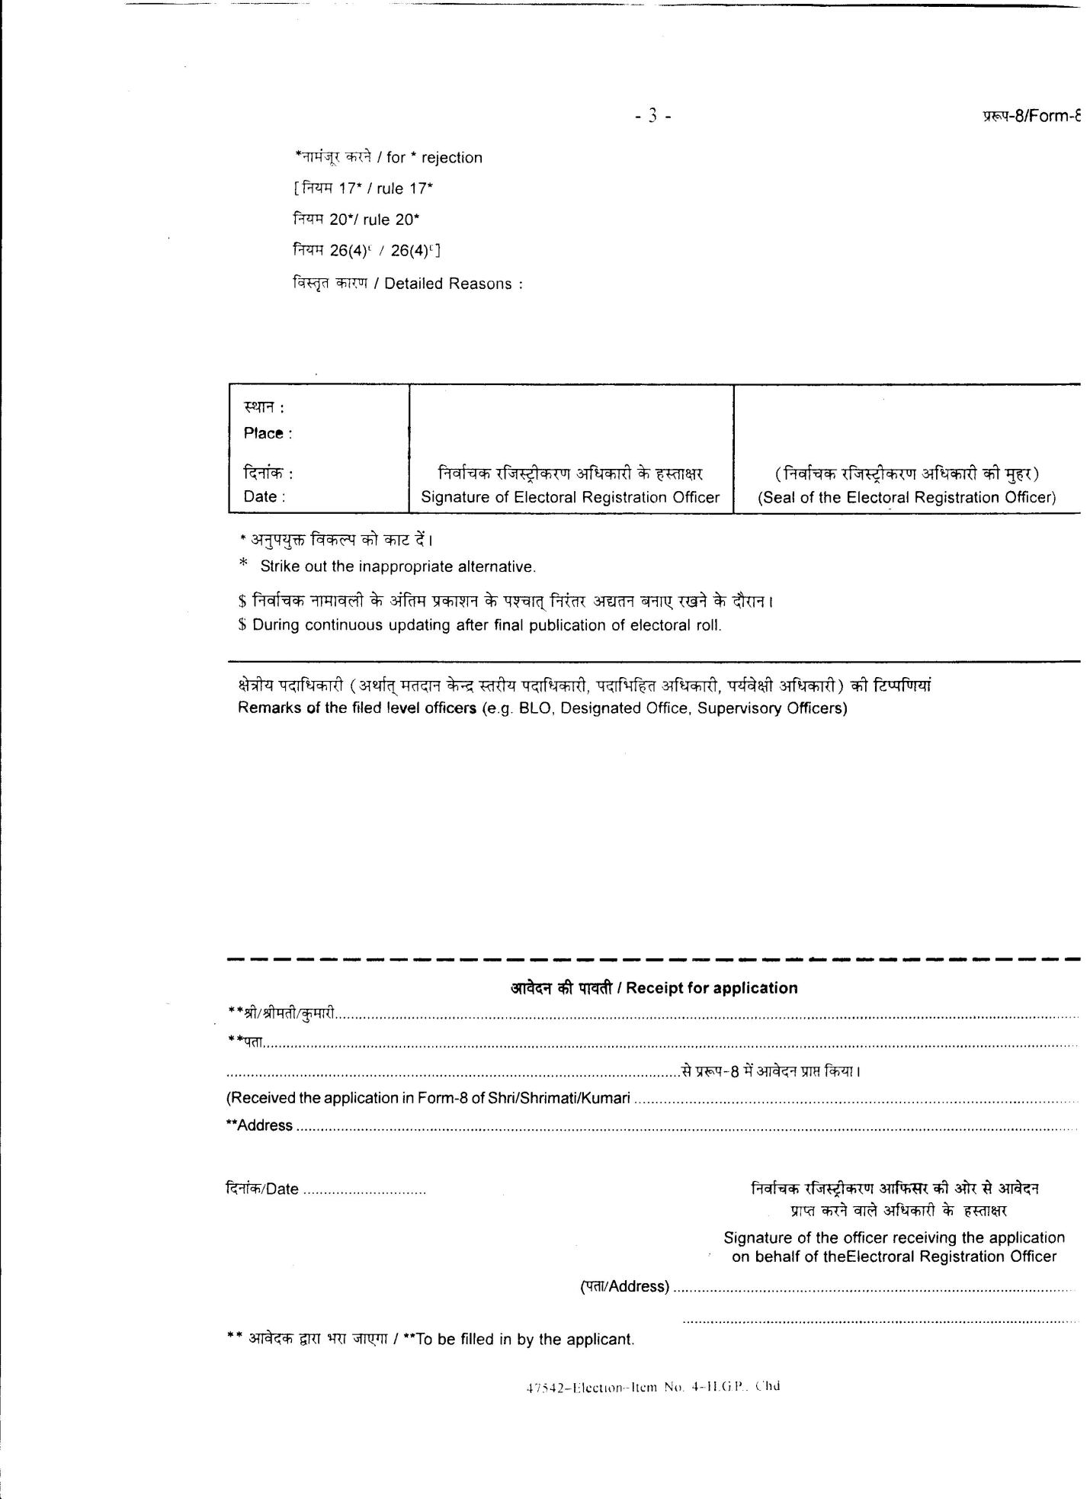

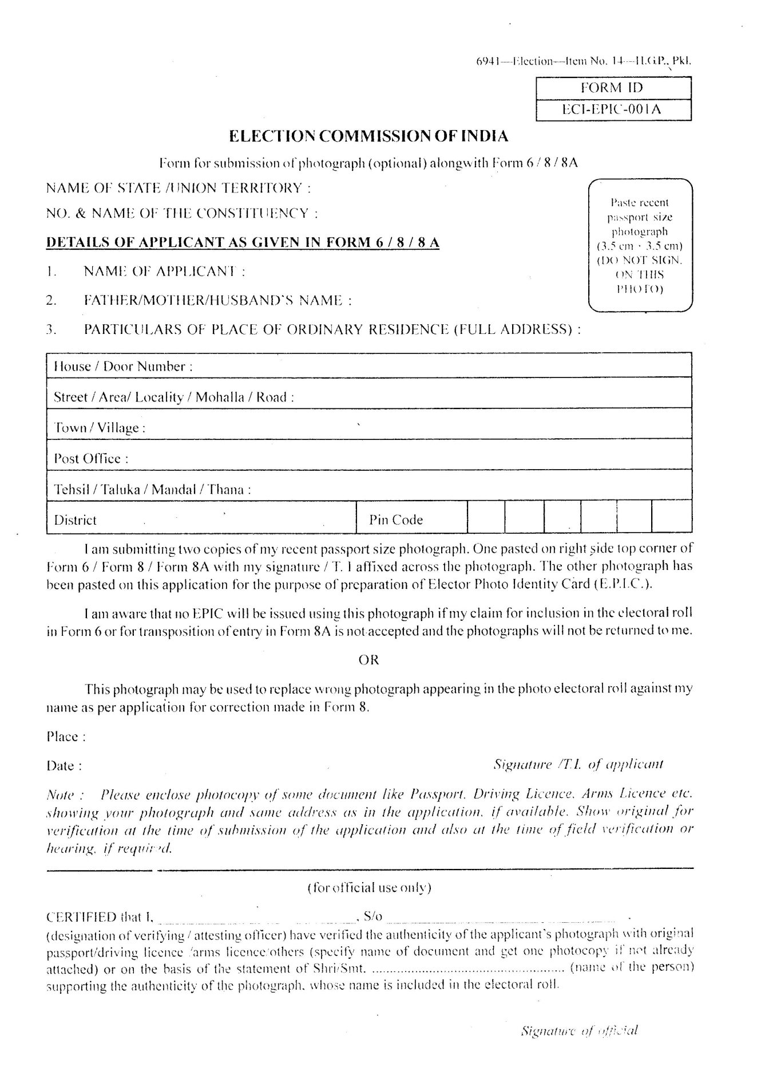

Form No. 7
The following Form No. 7 can be filled by a person whose name is already included in the electoral roll in order to object inclusion of a name or for seeking deletion of a name already included in the electoral roll.
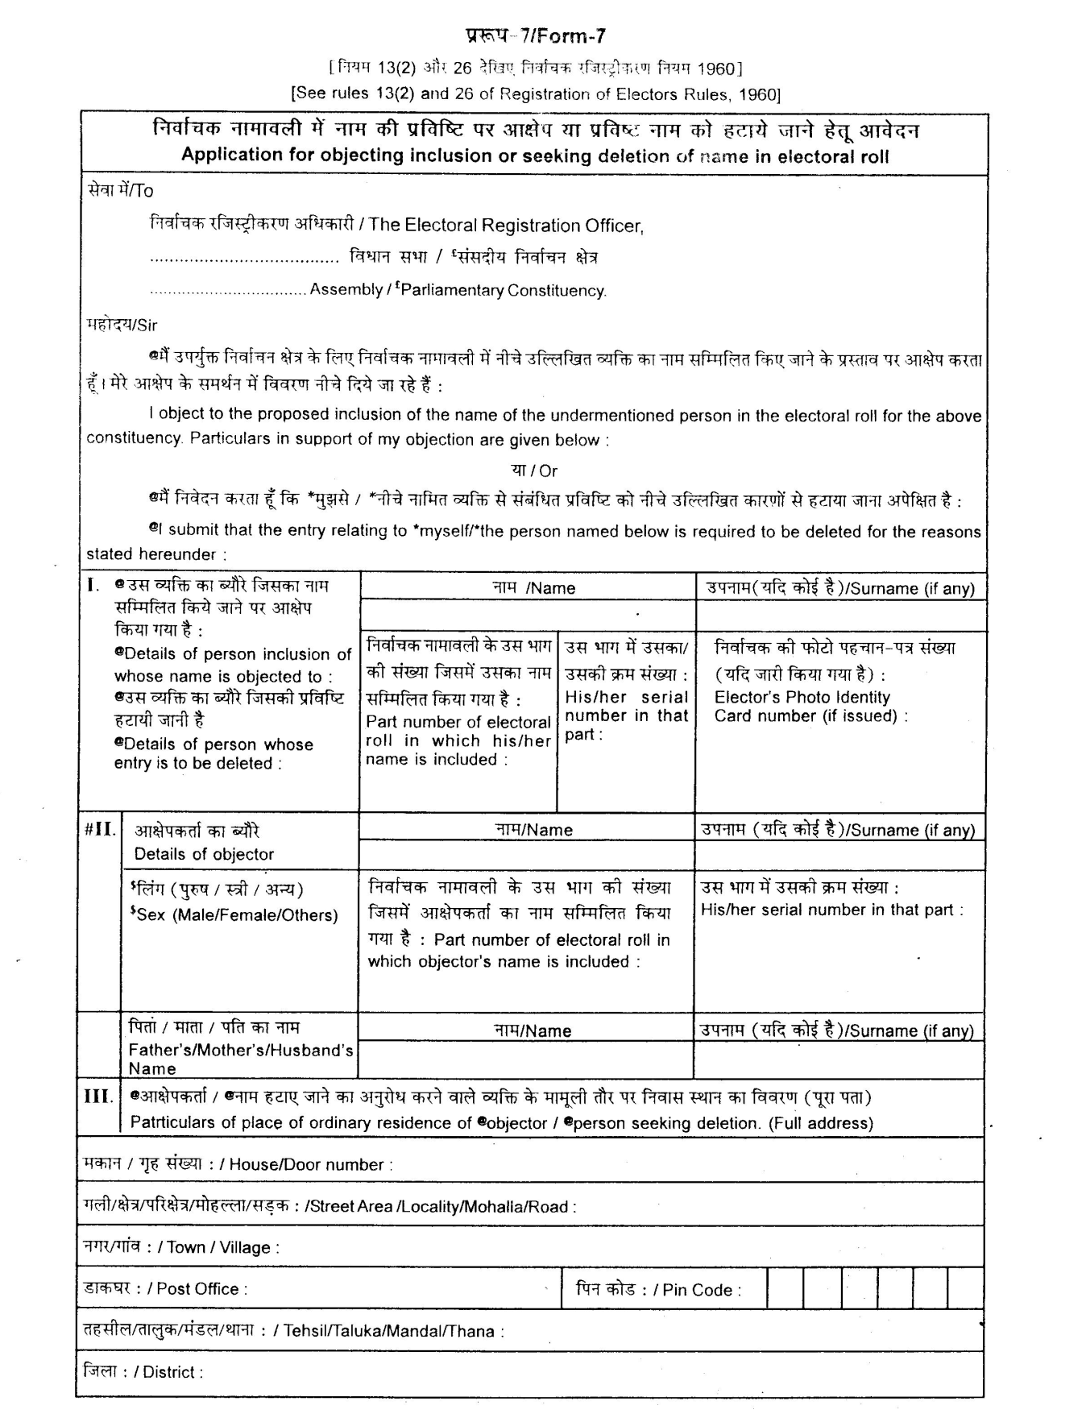

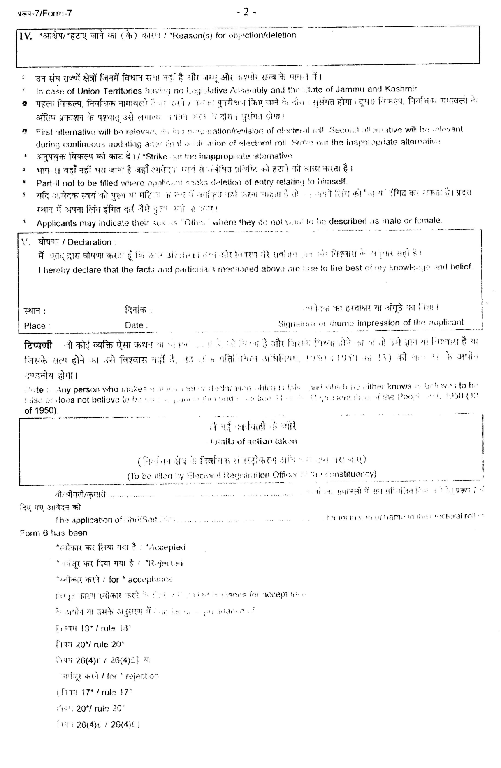

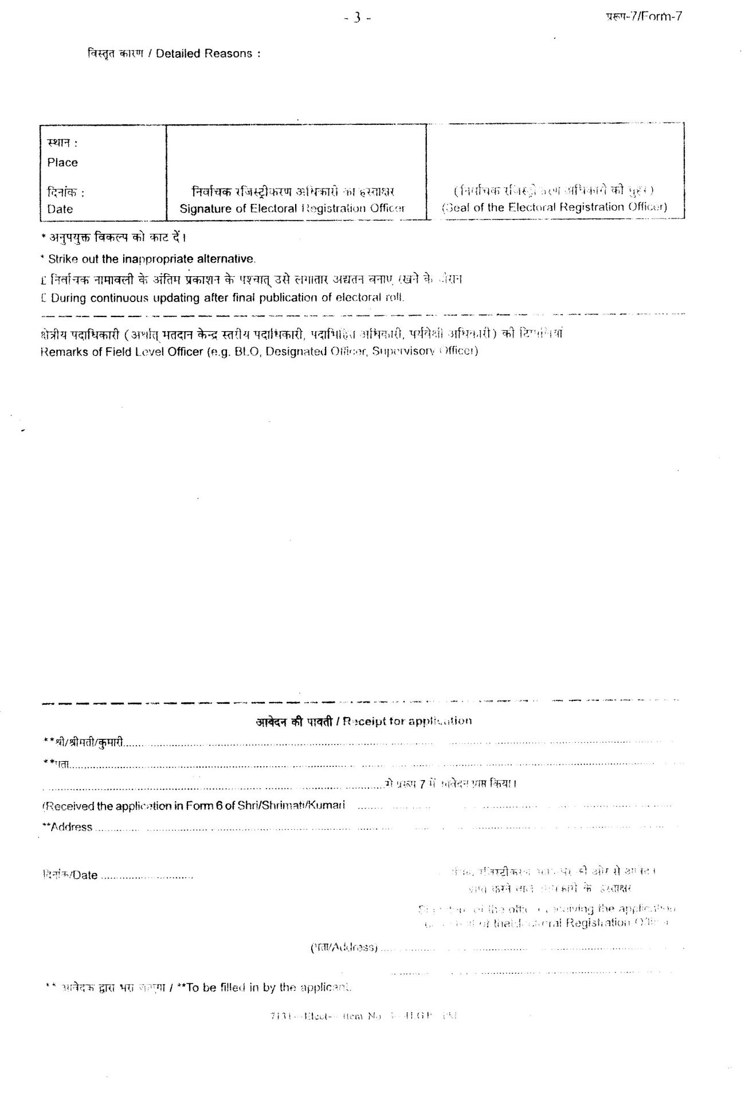

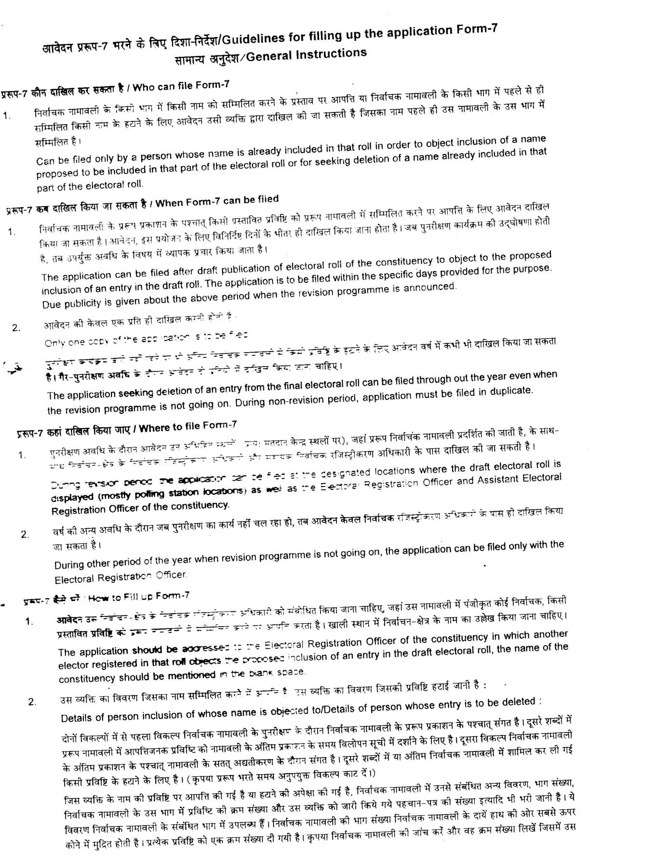

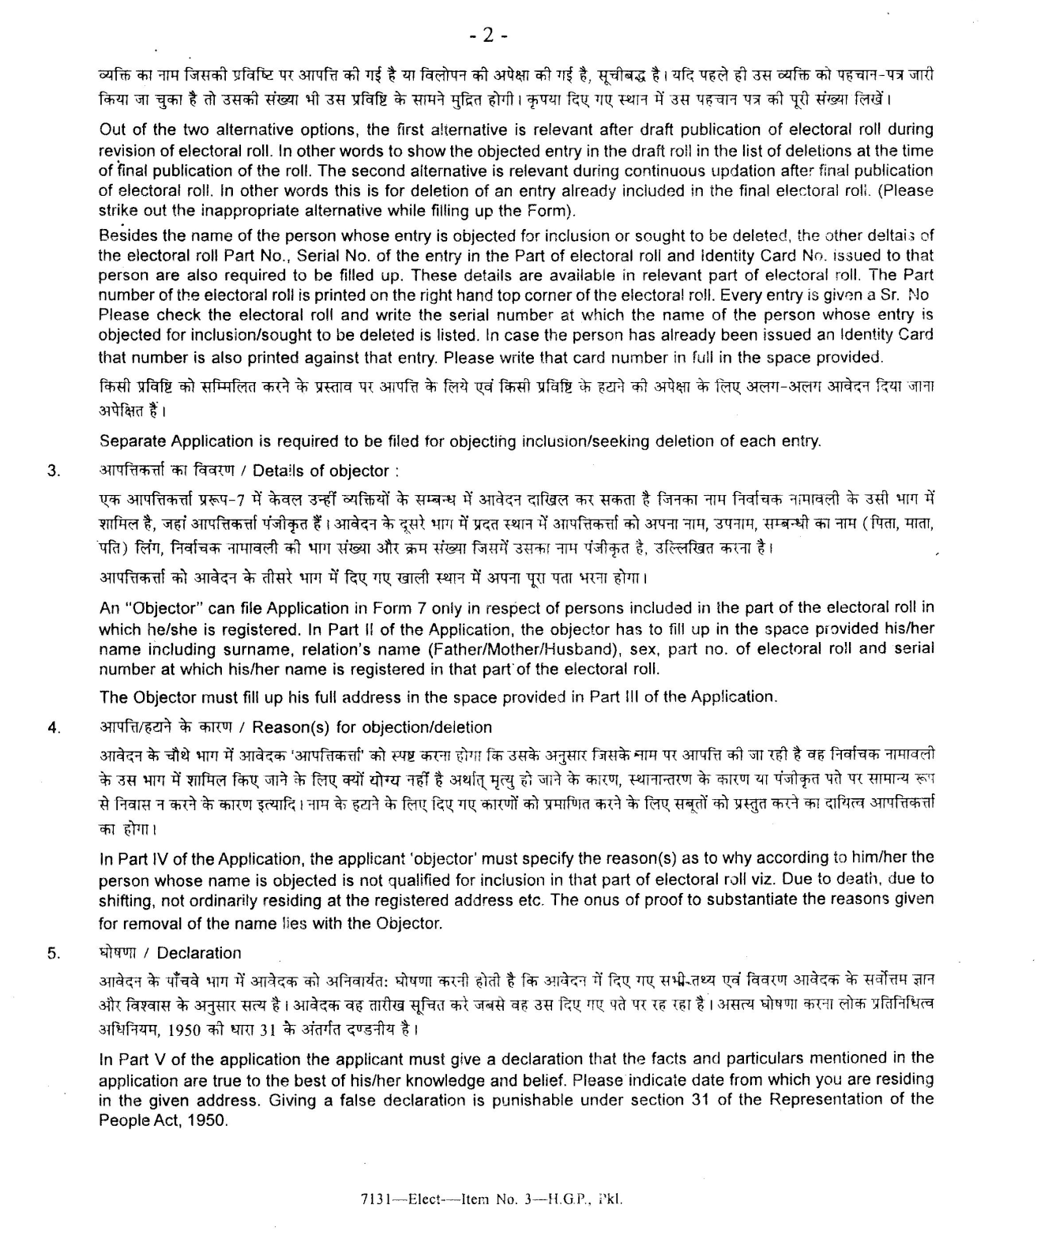

Form No. 8
The following Form No. 8 can be filled by a person whose name is already included in the electoral roll in seeking correction to his/her particulars already printed in the electoral roll.
