Dr. Vivek Kohli
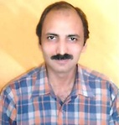 | Designation - Principal  Qualification - M.A.,(English), M.Ed., Ph.D.(Education)  Orientation/Refresher Courses attended - 4  Seminars/Workshops/Conferences attended -45  Papers Presented/Published -20  Ph.D./M.Ed./M.Phil Thesis Supervised -30  Membership of Various Committees/Associations/Societies etc.(has been or Presntly) -  Member, University Court, Kurukshetra University  Member, Academic Council, Kurukshetra University  Member, Faculty of Education, Kurukshetra University  Member, All India Association for Educational Research  Member, Indian Association of Teacher Educators  Awards/Honours received-  Recipient of Best Educationist Award Honoured by Smt.Geeta Bhukkal, Education & Health Minister, Haryana  Any Other Achievements -  Stood 2nd in Kurukshetra University M.Ed Exam  Stood 5th in Kurukshetra University B.Ed Exam  NCC 'C' Certificate Holder (Army Wing)  Red Cross Medal Certificate Holoder

Dr. Sushma Gupta
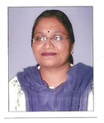 | Designation-Associate Professor  Qualification- M.Sc., M.Ed., Ph.D  Seminars/Workshops/Conferences attended -26  Papers Presented/Published -12  Ph.D./M.Ed./M.Phil Thesis Supervised -40  Membership of Various Committees/Associations/Societies etc.(has been or Presntly) -  Member, U G Board of Studies Kurukshetra University  Member, Faculty of Education, Kurukshetra University  Member, All India Association for Educational Research  Member, Indian Association of Teacher Educators  Member, Council for Teacher Education  Research Projects Undertaken-  A major research project titled ‘Effect of Different Teaching Strategies on the development of Environmental awareness, Attitude building and Implementation of Action Programme in Rural Youth of Haryana has been Sanctioned, by UGC with a grant of Rs. 6.88 Lakhs.  Awards/Honours received-  Awarded Junior Research Followship (JRF) from University Grant Commission  Any Other Achievements -  Passed M.Ed with Distenction Marks and got 5th Position in University Merit

Dr. Narender Kaushik
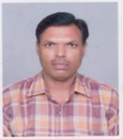 | Designation- Associate Professor  Qualification- M.A.(Hindi),M.Ed., M.Phil. (Edu.), Ph.D (Edu.)  Orientation/Refresher Courses attended - 04  Seminars/Workshops/Conferences attended -29  Papers Presented/Published -15  Ph.D/M.Ed./M.Phil Thesis Supervised-46  Membership of Various Committees/Associations/Societies etc.(has been or Presntly) -  Member, Academic Council, Kurukshetra University  Member, All India Association for Educational Research  General Secretary, Net Ball Association(Ambala)

Dr. Neelam Luthra

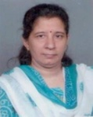 | Designation- Associate Professor  Qualification- M.A., (English), M.Ed., Ph.D  Orientation/Refresher Courses attended - 05  Seminars/Workshops/Conferences attended -29  Papers Presented/Published -12  Ph.D./M.Ed./M.Phil Thesis Supervised-22  Membership of Various Committees/Associations/Societies etc.(has been or Presntly) -  Life Membership of AIAER  Member CTE  Awards/Honours received-  Young Researcher Awaard by AIAER  Award by Rotary Club Ambala Central for Coordirating Vocational Guidance Centre  Any Other Achievements -  Delivered Lecturers at various colleges , Institutions on theme of Education & Spiritual  Conducted Workshops in spoken English amd Pronunciation for Teachers and Students in the Language Lab

Dr.Satnam Kaur
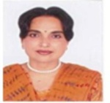  - | Designation- Associate Professor  Qualification- M.Sc., M.Ed., M.Phil., Ph.D  Orientation/Refresher Courses attended - 04  Seminars/Workshops/Conferences attended -15  Papers Presented/Published -04  Ph.D./M.Ed./M.Phil Thesis Supervised-08  Membership of Various Committees/Associations/Societies etc.(has been or Presntly) -  Life Membership, All India Association for Educational Research  Member, Council for Teacher Education  Any Other Achievements -  Stood 4th in Panjab University in M.A.(Fine Arts)

Dr.Pooja
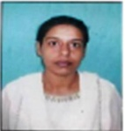 | Designation-Assistant Professor  Qualification-M.A., M.Ed., Ph.D

Mr. Pawan Bhatia
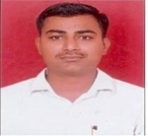 | Designation- Assistant Professor  Qualification- M.A., M.Ed. (Spl. Edu.), M.Phil.(Political Science),UGC NET in Education  Seminars/Workshops/Conferences attended -10

Dr. Nirmal Goyal
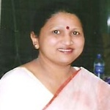 | Designation-Librarian  Qualification- M.A., M.Lib & Inf. Sc., Ph.D.(Lib.& Inf.Sc.)  Orientation/Refresher Courses attended - 04  Seminars/Workshops/Conferences attended -29  Papers Presented/Published -17  Ph.D./M.Ed./M.Phil Thesis Supervised -2  Membership of Various Committees/Associations/Societies etc.(has been or Presntly) -  Life Membership of Indian Library Association and Haryana Library Association.  Member, Board of Under Graduate Studies in Education, Kuk 2002-2004  Awards/Honours received-  Sliver Medal in B.Lib & Inf. Sc. in 1985 (Ist Positionin KUK)  National Merit Scholarship during M.Lib & Inf.Sc. (1986)  Any Other Achievements -  3 day INFLIBNET Training Programme on Library Automaton from Nov.1-3, 2003 Organized by Library & Information Centre.  Conducted one day Workshop on Uses of Library Software for Library Professionals held in Library of Sohan Lal DAV College of Education on 17 aug 2002

Dr. B S Wadhwa

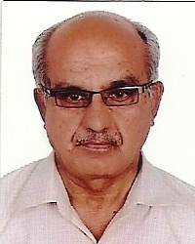 Designation: Associate Prof.

Qualifications : M.Sc. (Psy.), M.Ed., Ph.D (Edu.)
Seminars/Workshops/Conferences attended:
Paper presented/published: 10
Ph.D/M.Ed./M.Phil Thesis supervised: Two (Ph.D.)
Sixty (M.Ed.)
Membership of Various Committees/Associations/Societies etc. (has been or presently)
Acted as resource person in a number of conferences/seminars/workshop
Life member of DAV Managing Committee, New Delhi
Faculty Members (Education Faculty) of Punjab University for some time during my stay at DAV College of Education, Abohre
Award/Honours Received: 1. First Class in M.Ed. in K.U.K.
2. First in Certificate Course in Russian in K.U.K.
3. Second in Diploma in French in K.U.K.
Any other Achievements
1. Retired as Associate Prof. from DAV College of Education, Abohar
2. Book on Researh and Statistics in Education (in English and Hindi) Published by 21st Century Publication, Patiala
3. Applied good research techniques in guiding Ph.D and M.Ed. Dissertations like Q-methodology semantic differntial technique, Factor Analysis & Factonial Analysis of Variance etc.

Dr. Mukesh Ahlawat
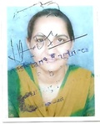 | Designation-Assistant Professor  Qualification- M.A.(Eco.), M.Ed., Ph.D.(Education)  Seminars/Workshops/Conferences attended: 10  Papers presented/published: 8  Ph.D/M.Ed./M.Phil Thesis supervised: 10

Mrs. Ruchi Manchanda
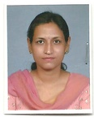 | Designation- Assistant Professor  Qualification- M.Sc. (Maths), M.Ed.,M. Phil (Edu.), UGC NET  Seminars/Workshops/Conferences attended: 7  Papers presented/published: Presented: 1, Published: 1  Ph.D/M.Ed./M.Phil Thesis supervised: 6  Membership of Various Committees/Associations/Societies etc. (has been or presently)  - Legal Literacy Cell  - Red Ribbon Club

Mrs. Sheetal Batra
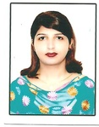 | Designation- Assistant Professor  Qualification-M.Sc, M.Ed., M.Phil.(Maths.), M.Phil. (Edu.), UGC NET, JRF, STET  Seminars/Workshops/Conferences attended: 7  Papers presented/published: Presented: 3, Published: 3  Membership of Various Committees/Associations/Societies etc. (has been or presently)  - Maths Club  Awards/Honours received:  - Honoured by DAV College Managing Committee, New Delhi  - Gold Medallist in M.Ed.

Ms. Garima Batra
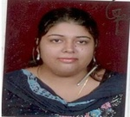 Designation- Assistant Professor
Qualification- M.Sc. (Maths), M.Ed., UGC NET, JRF, CTET (Edu.), HTET
Seminars/Workshops/Conferences attended: Seminars-5, Workshops-1
Papers presented/published: Presented: 5, Published: 2
Awards/Honours received:
- 2nd position in KUK in M.Ed.
- 1st in college and 2nd in KUK in B.Ed.
- 7th in KUK in B.A. III
- 1st in college in all the three years of B.A.
Any other achievements:
- 7th in District Science Essay Writing Competition
- 1st in Intra College Quiz
- 2nd in Speech and Poetry
- Prizes won in essay writing contest by Haryana State Council for Science & Technology

Ms. Kamini
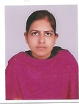 | Designation- Assistant Professor  Qualification- M.A. (Eco.), M.Ed., UGC NET (Edu.),CTET, HTET (TGT & PGT)  Seminars/Workshops/Conferences attended: 10  Papers presented/published: Presented: 5  Awards/Honours received:  4th position in M.A. (Eco.) in KUK  Any other achievements:  Cleared CTET (PRT), HTET (TGT) and HTET (PGT)

Mrs. Monika Sharma
Designation-Assistant Professor
Qualification- B.Sc., M.Ed., UGC NET (Edu.)
Seminars/Workshops/Conferences attended: 03

Awards/Honours received : Gold Medalist (M.Ed.)

Dr. Kamlesh Kumari
Designation-Assistant Professor
Qualification- M.A. (Hindi), M.A. (Skt.), M.Phil (Skt.), M.Ed., UGC-NET (Skt.)
√
Papers presented/published: 03

Mr. Jasbir Singh
Designation-Assistant Professor
Qualification- M.A. (Eng.), M.Ed., UGC NET (Edu.)

Awards/Honours received : Best Actor in 33rd Inter Zonal Youth Festival at KUK

Sh.O.P. Luthra
Designation- Instructor (Physical Education)
Qualification- B.A., D.Ed.

Ms. Gurpreet Kaur
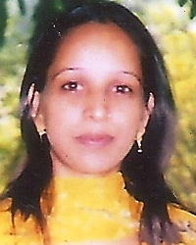
Ms. Mamta Sehgal
